Process Financial Data with Tableau

Rao Katie Xu

Environment: Win10 64 bit (Parallel Desktop on Mac OSX Yosemite 10.10.5 )

Tableau: <http://www.tableau.com/products/desktop/download>

*Project:*

Datasets: <https://www.superdatascience.com/tableau/>

Download: Bank Customers.csv

Aim: Find the profit margin of each city.

Part of the table:

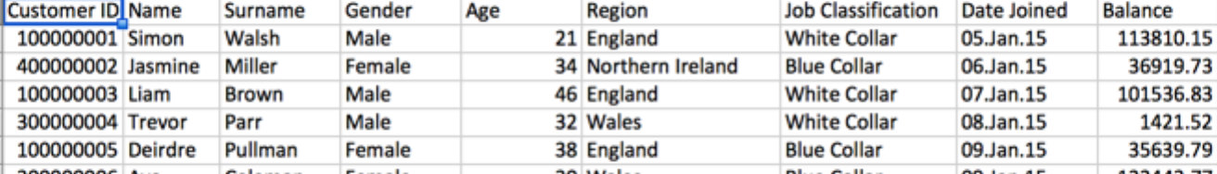

Open the file, but the problem is Tableau cannot understand where is England or Northern Ireland. The map is empty, so we need to change Region to Geographic role that Tableau can recognize. Just right click the Region-> Geographic Role-> State/Province. (The United Kingdom is made up of the countries England, Scotland, Wales, and Northern Ireland. So we choose State/Province, not country)

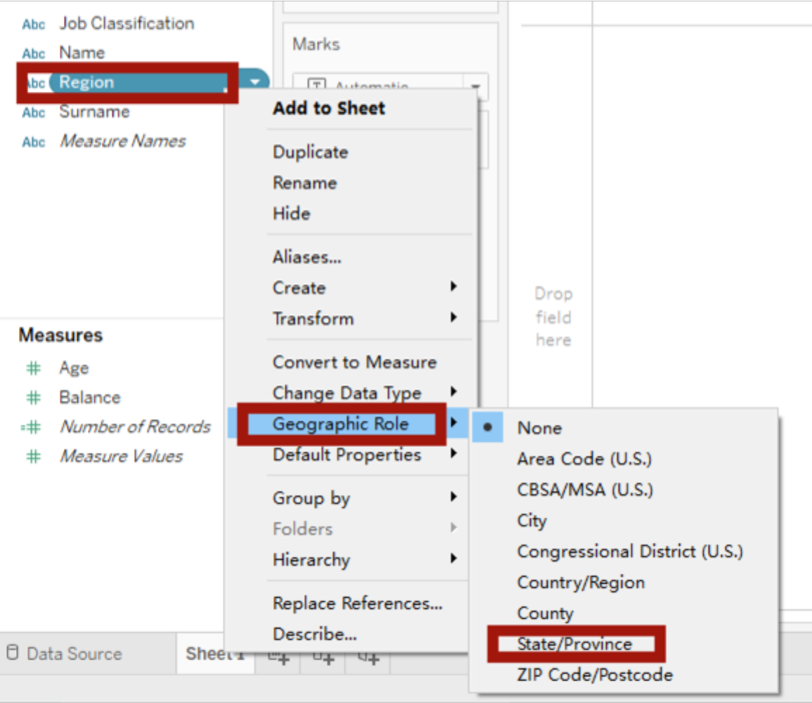

Now we can see the Region has a little global sign that it is a geological sign. Drag the Region to the blank space of sheet1, we can see the map shows up.

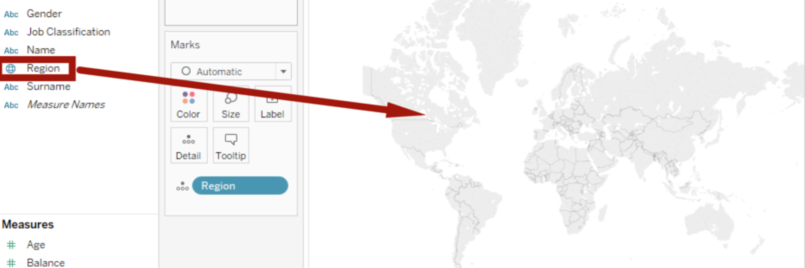

Go click 4 unknown, choose Edit Locations…,

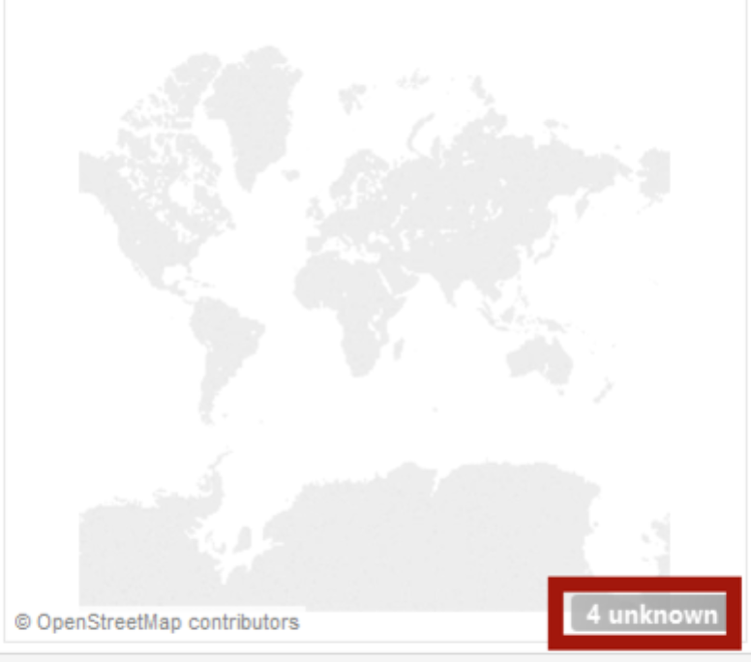 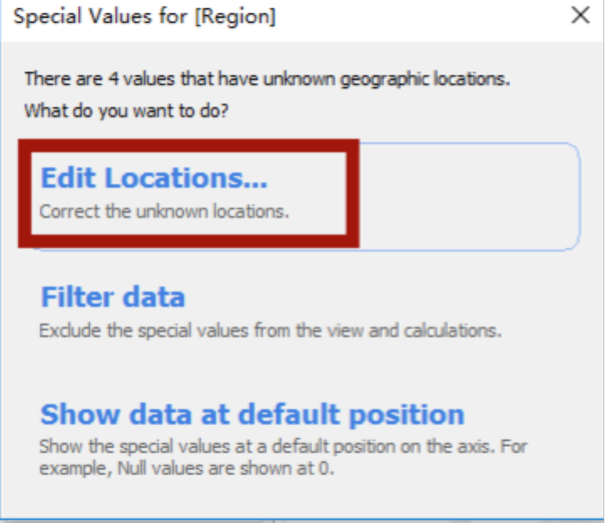

Then we go choose United Kindom. Now the map is fixed. Go Marks, choose Filled Map, now we can see blue area.

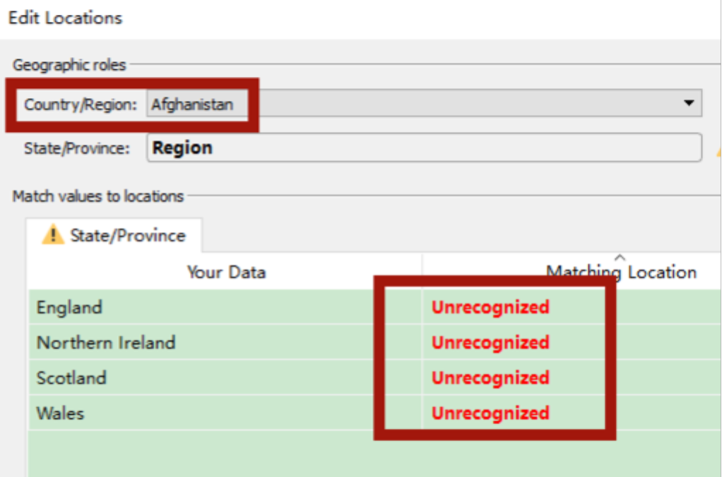 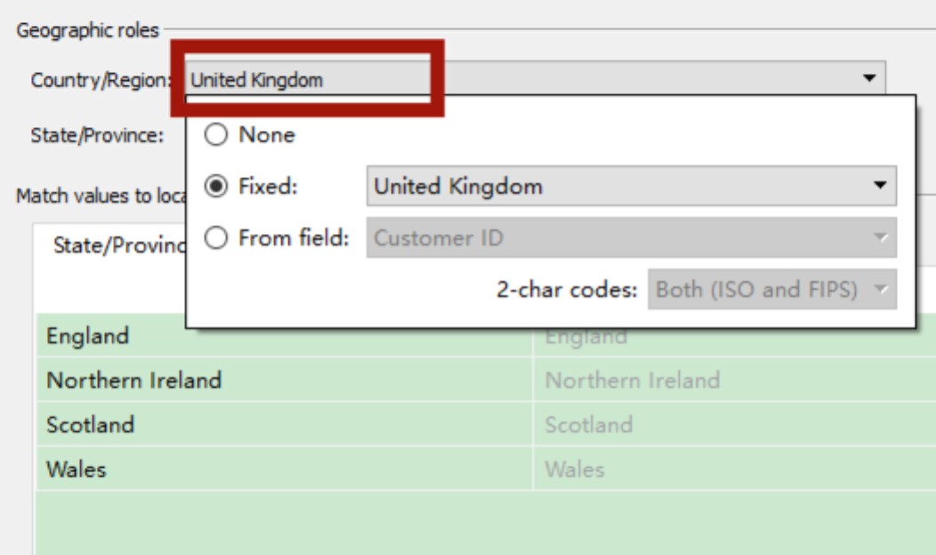

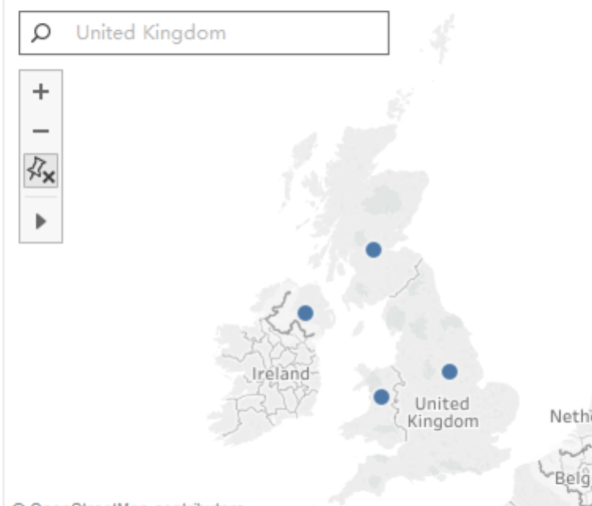 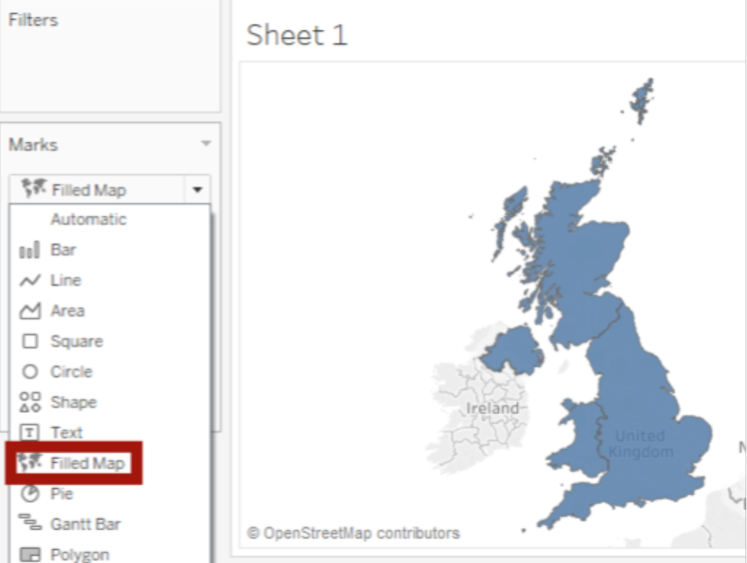

Now drag Region to Color, drag #Number of Records to the Label, and right click the SUM(Number of Records) to adjust the format of the records numbers.

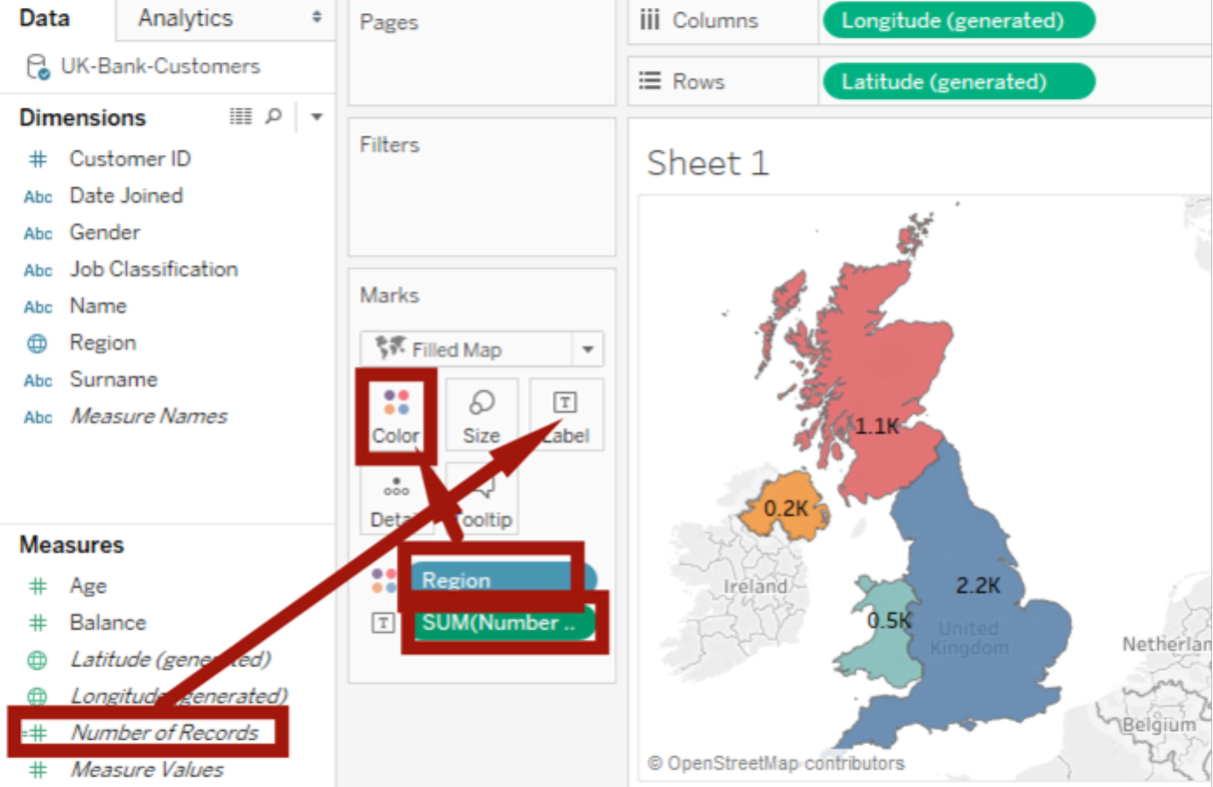

Now name the first sheet1 as Map, new another worksheet, just drag the Gender into the sheet and we can see the table with Rows of Gender

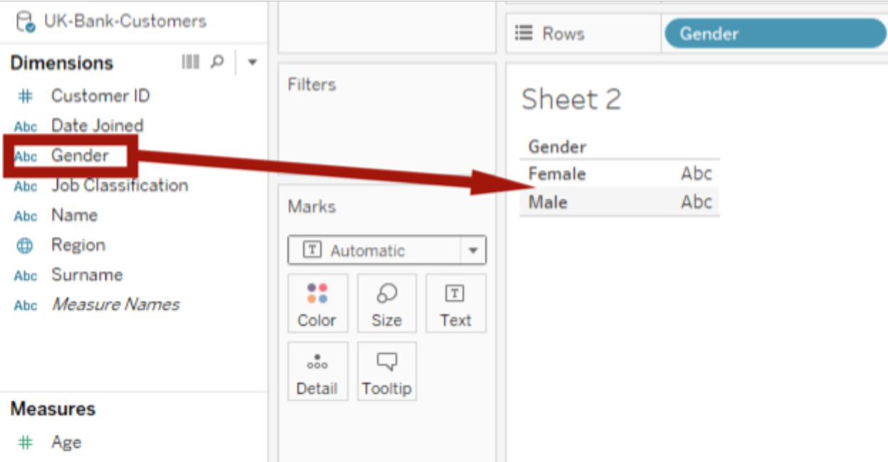

Attention: if you choose Pie in the Marks, it will show two circles. So we need to go to Show Me, and choose the pie chart, and then add labels and change color to make it prettier.

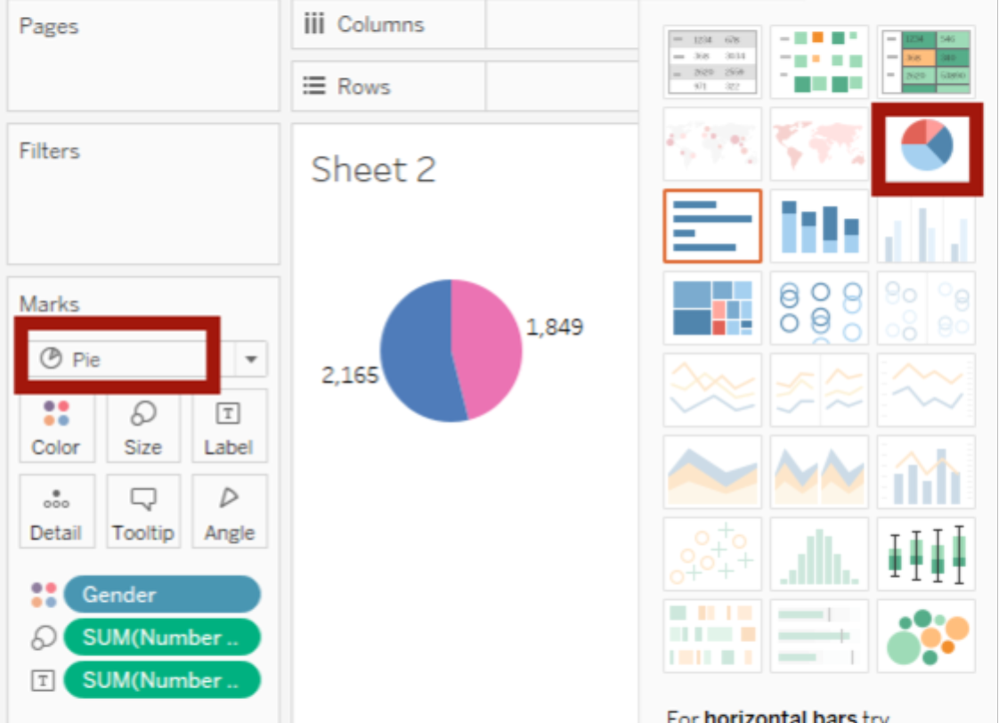

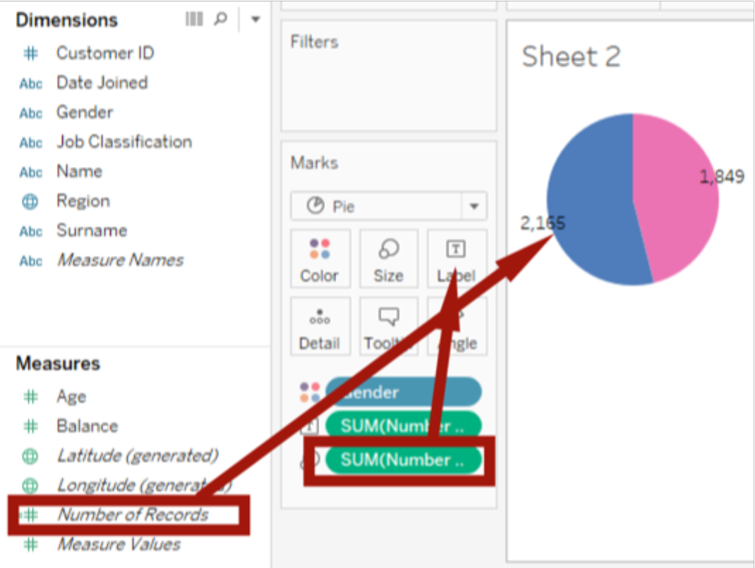

However, we are not interested into the numbers. We want to see the percentages. The quickest way is to right click the SUM(Number of Records) (with label sign), choose Quick Table Calculation-> Percent of Total. But we want to show like percent. Still right click the SUM(Number of Records), choose Format-> Number -> Percentage

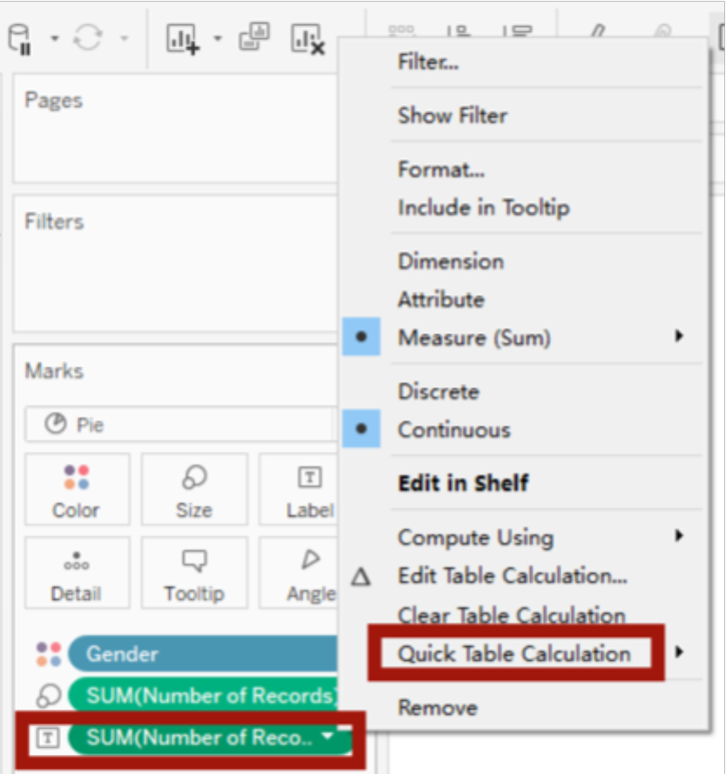 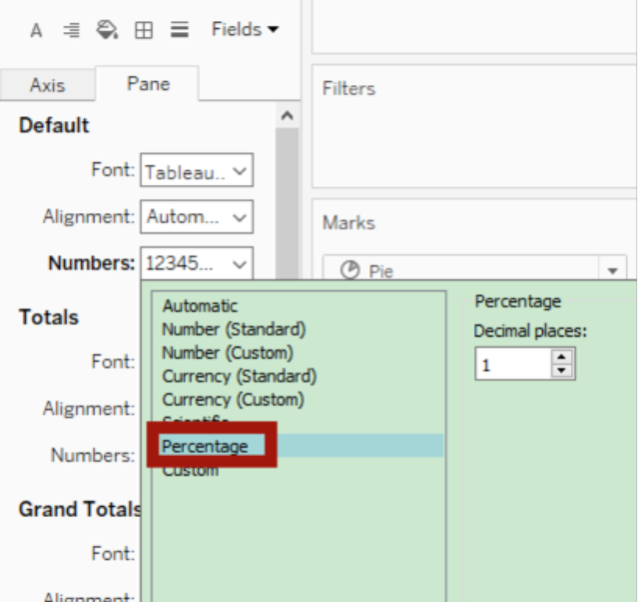

Now we have the female and male percentage.

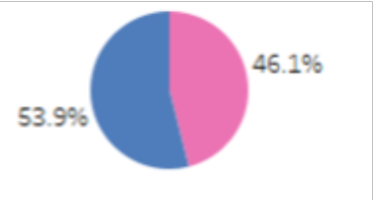

Now we want to see the age distribution of the record.

New a worksheet, and drag the #Age into the Columns, and right click the Age, choose Dimension, now we can little lines (if don’t choose Dimension, you might not see anything on the graph).

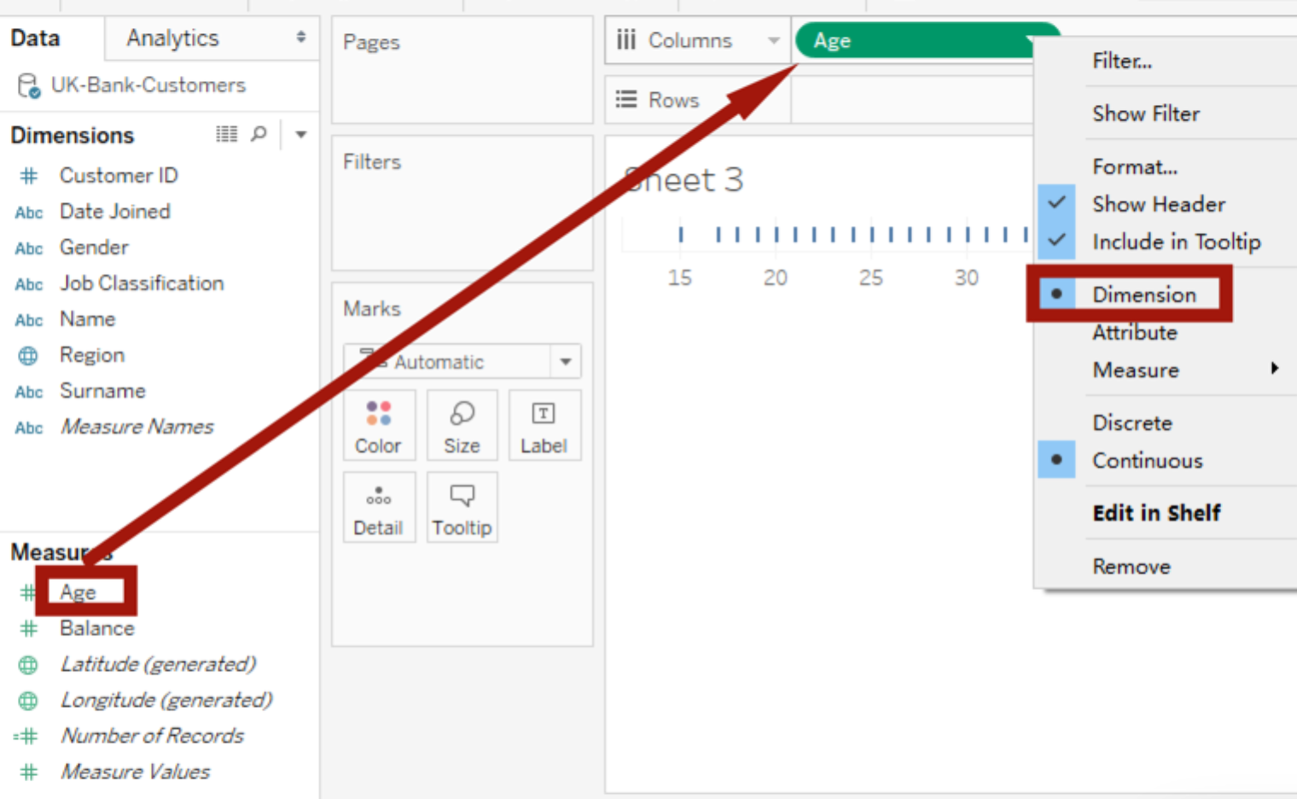

Now we add Number of Recorders. In our Bar graph, we notice age will show as individual year, such as 20,21,22. What if we need to show a range like 20-25, 25-30 or the age is not integer? Now we are using bins.

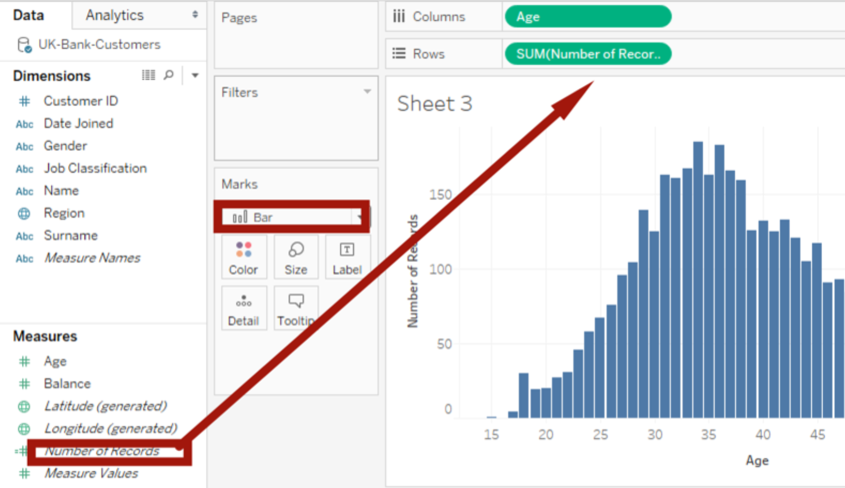

Now we clear all data and start over.

Just right click the Age, choose Create-> Bins. When the window pops up, choose 5, which means range is 5.

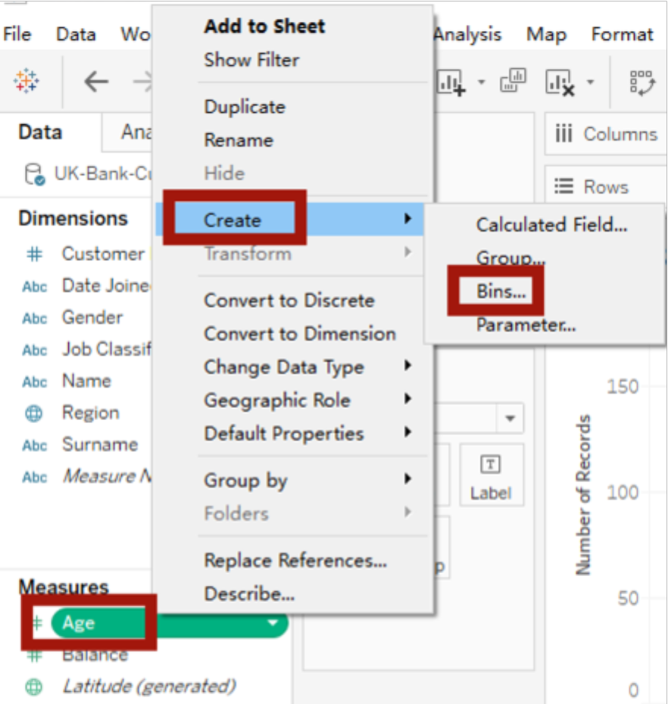 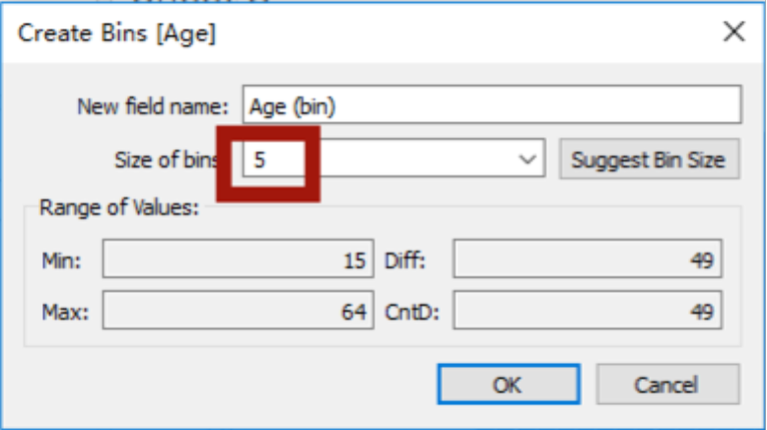

Now we drag Age(bin) into Columns and Number of Records into Rows, and also choose Bar type of graph.

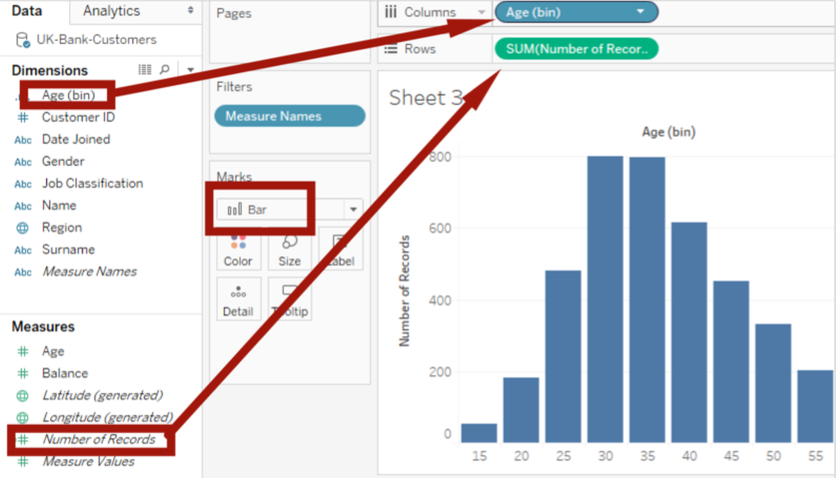

Also, we need the percentage. We don't need numbers because in the geographical graph we already know the total numbers. So we need to calculate percentage. Press Ctrl, drag SUM(Number of Records) to the label till we can see the numbers on the top. Right click the SUM(Number of Records), choose Quick Table Calculation -> Percent of Total. (If the number is not changing, go down to the SUM(Number of Records) in the Marks to do the same operations.) Like previously mentioned, we can change to percentage format.

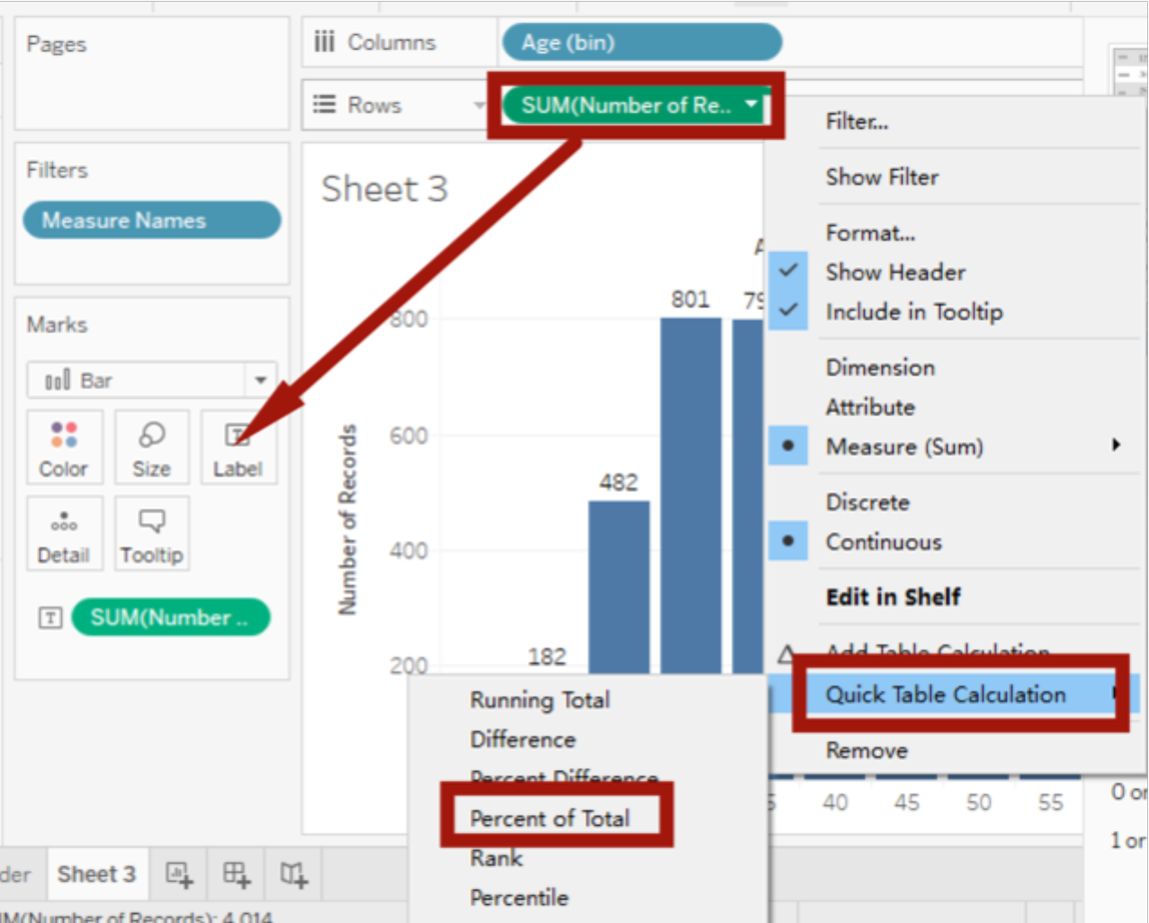

Now we want to change color, since green meaning money, so we still use blue. Just drag SUM(Number of Records) to the Color. Done!

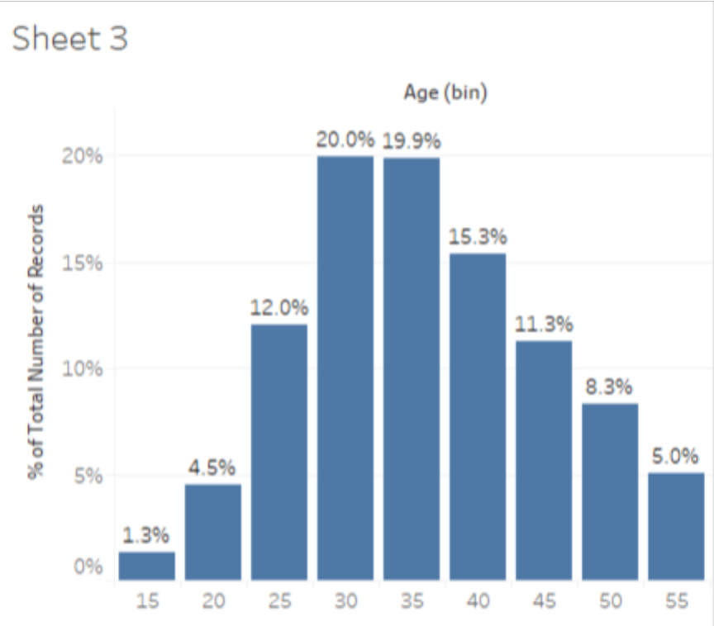 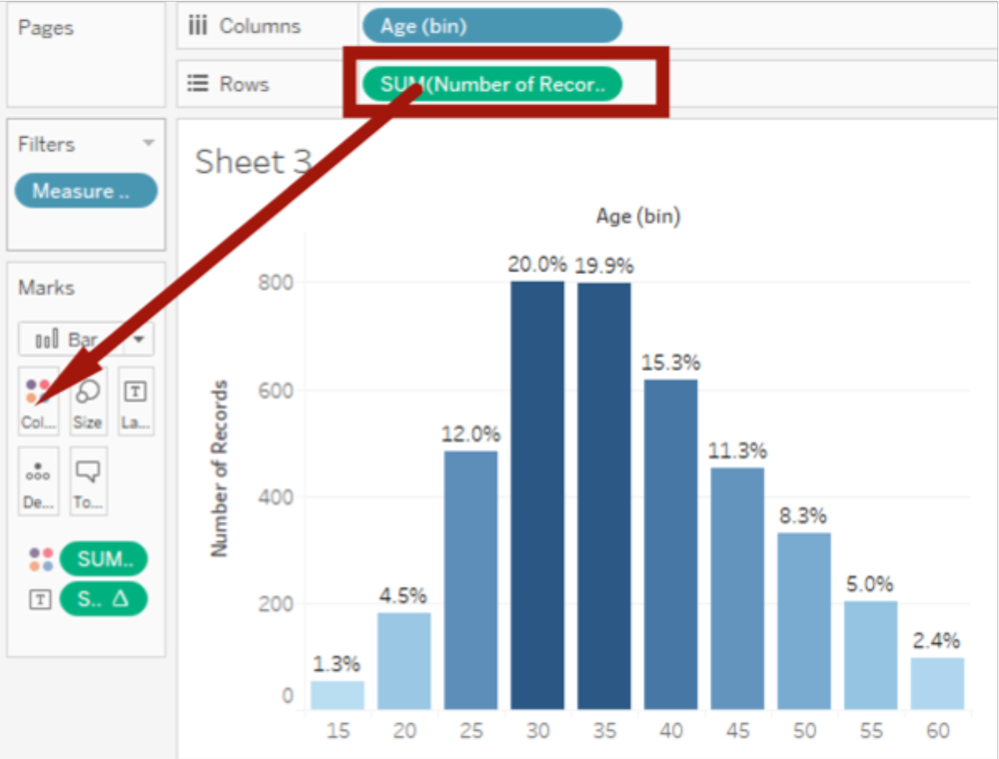

Now we need the leveraging the power of parameters(get the distribution by balance)

First, we create Balance Bins by right clicking the Balance->Create->Bins, and change Size of bins to 10000.

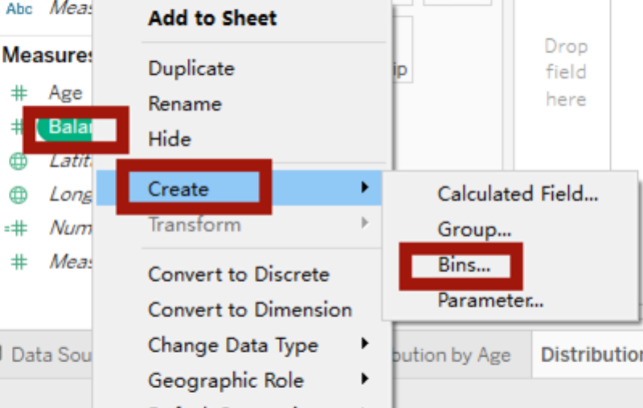

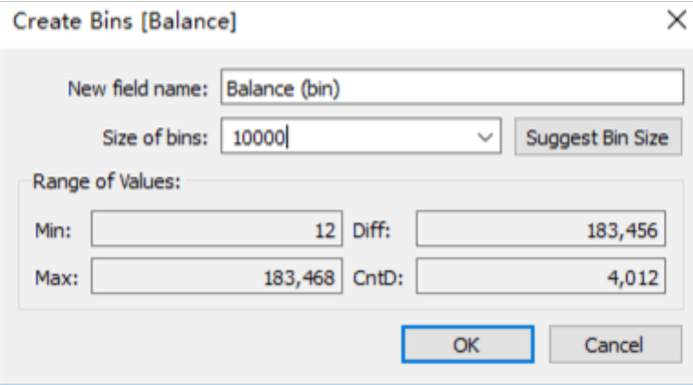

Now, like the previous bar graph, we can have the similar leverage graph. We can change to Percentage, change color and number format. However, we notice at the right down corner, there is a null because the number range is missing. We can delete this, but recommended to keep it. Right clicking the “1 null” we can hide this tag.

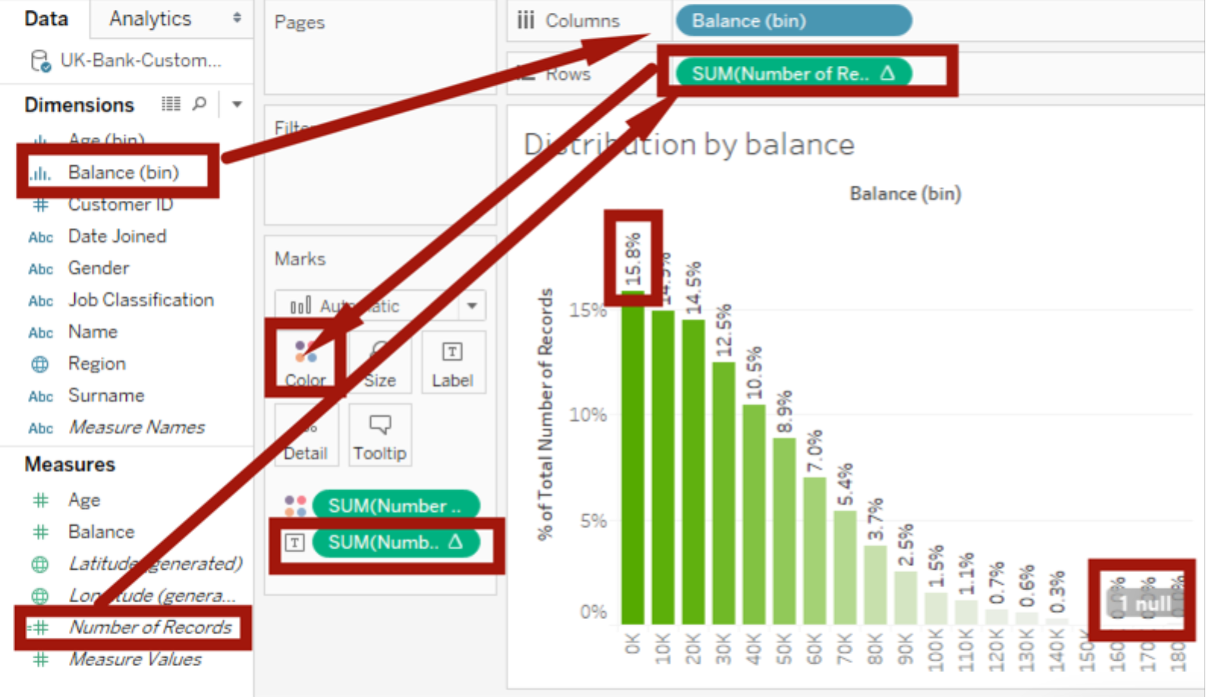

But we have better way to show this graph dynamically by changing bins. Right click the blank area on Measures panel to choose Create Parameters.

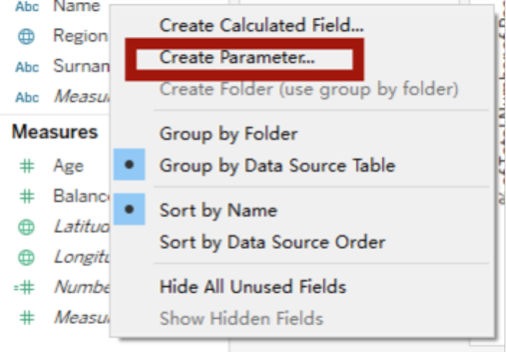

Give a name called Balance Groups (This will be the slide bar name), Date type: Integer, Current value: 10000, Range-> Minimum:10000, Maximum:25000, Step Size:$5000. Click OK. Now a small Parameters will show up.

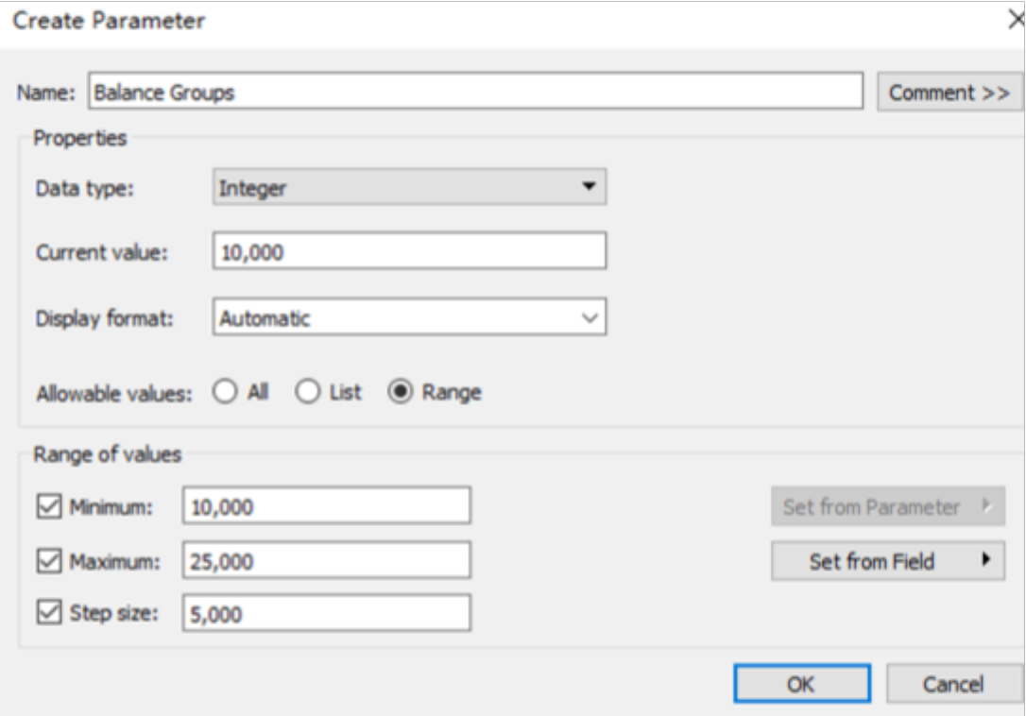 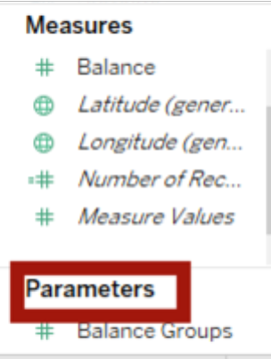

Right click Balance Groups, choose Show Parameter Control, then we can see the slide bar on the right top.

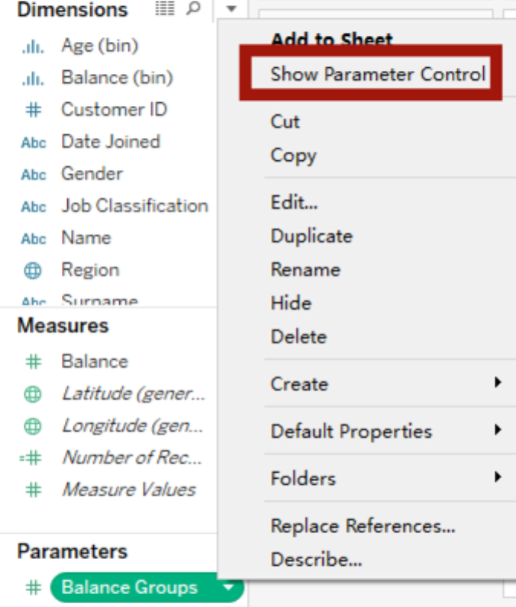 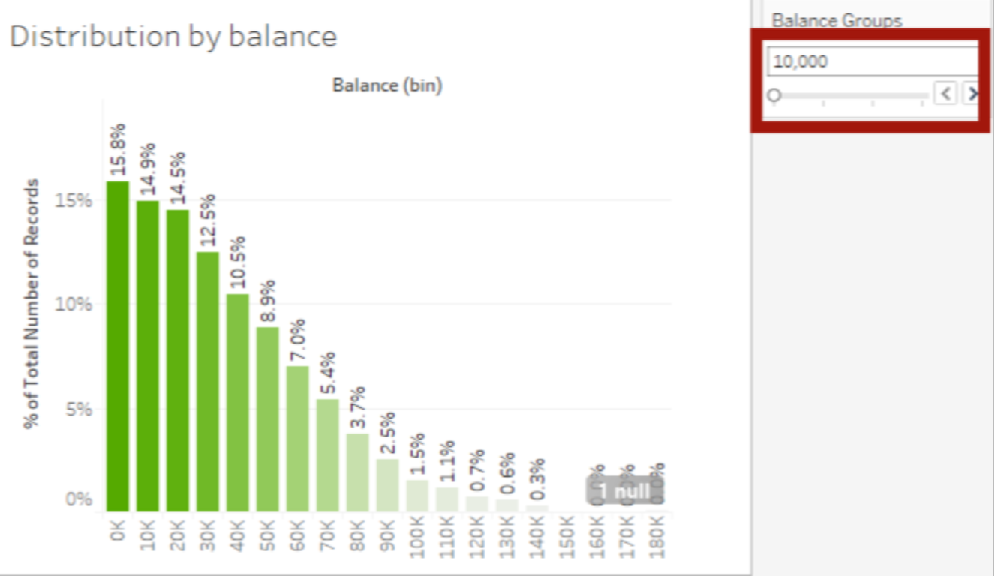

But the graph is not moving when sliding the bar, so we need to build the connection. Right click the Balance (bin) -> Edit, choose Size of bin to Balance Groups.

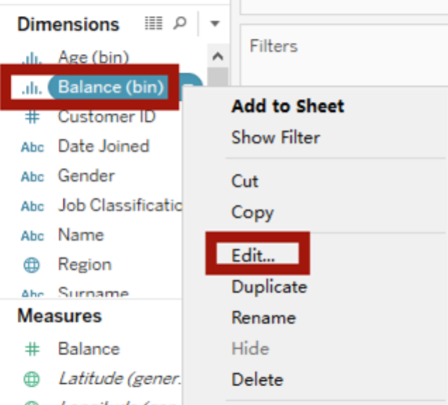

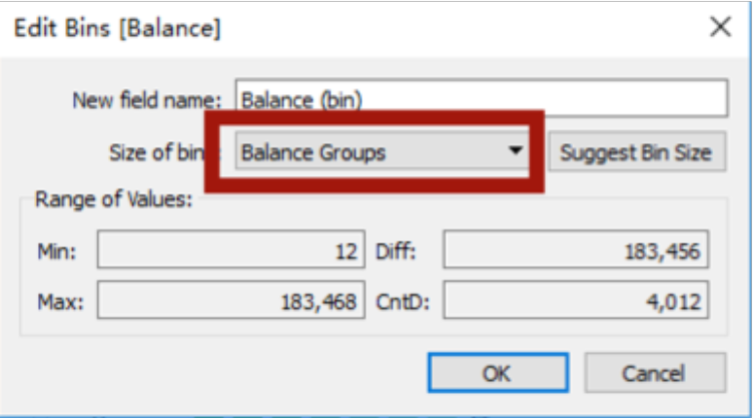

Now when slide the bar, we can see the graph changing by the Balance Groups.

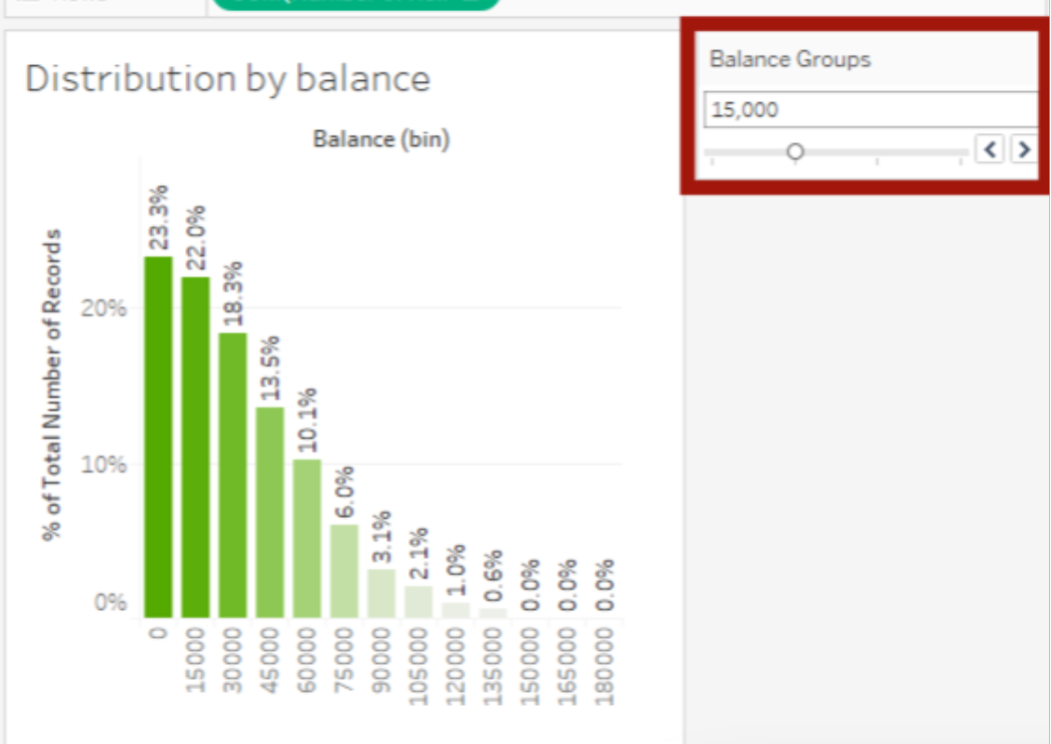

Create TreeMap chart. Just drag Job Classification to Columns, #Number of Records to Rows, and choose TreeMap chart. Actually we can just adjust the graph’s size to make it look packed.

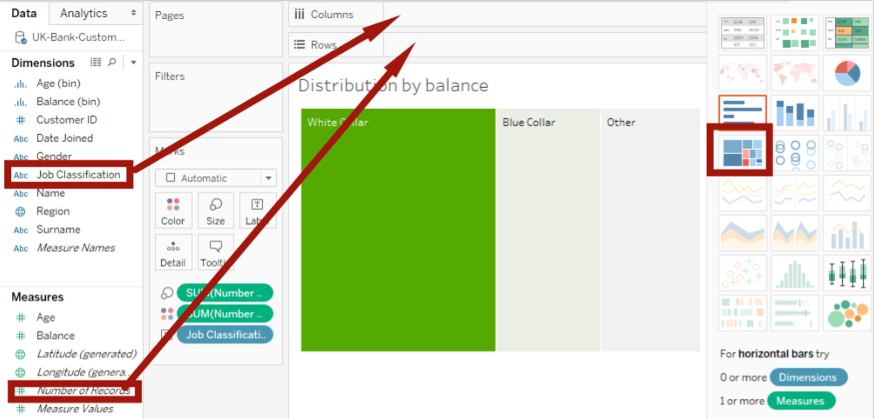

And we need to get rid of default SUM(Number of Records) color and drag Job Classification to the Color.

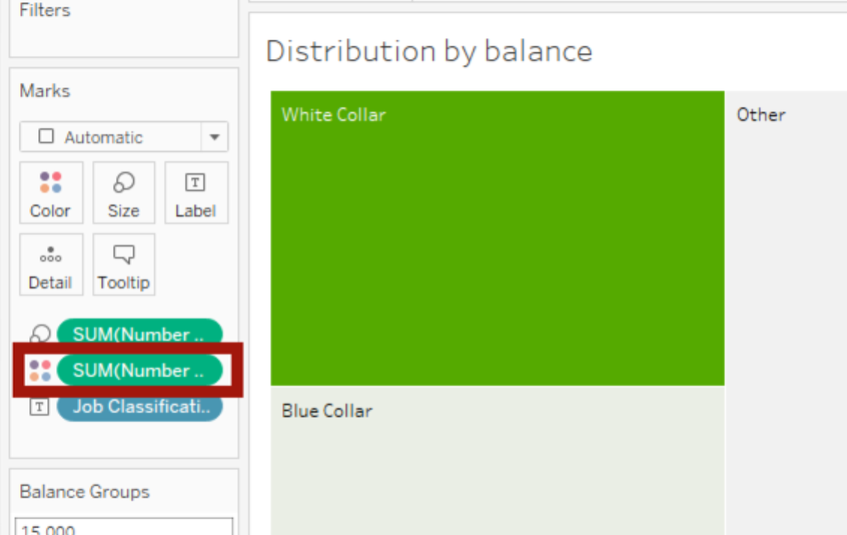

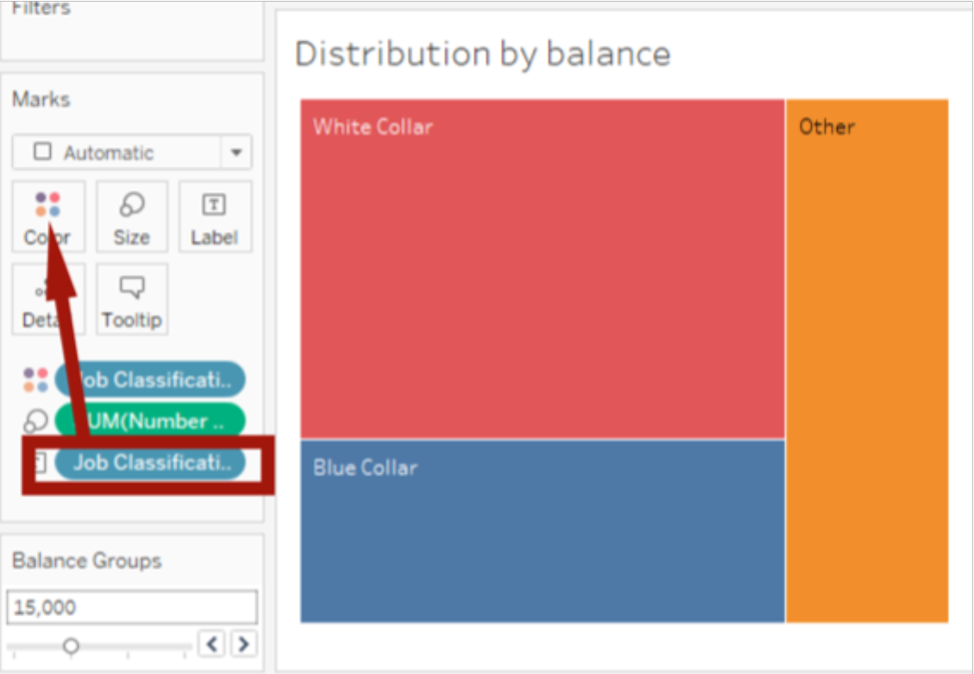

Now we want to put all graphs into one screen, just new a dashboard and drag all graphs here.

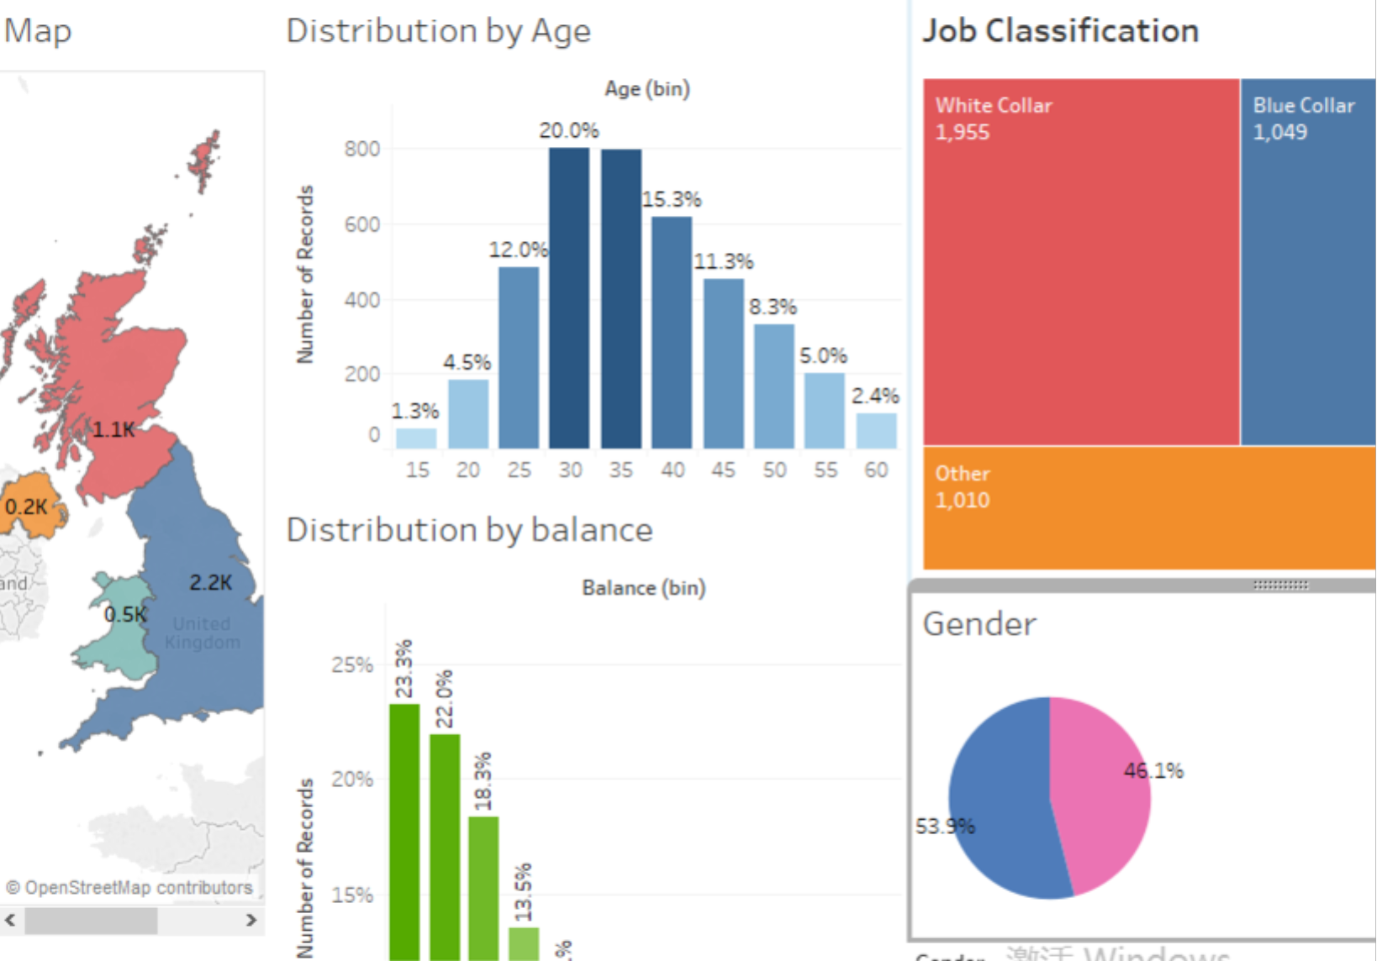

If you accidentally delete the parameter-dashboard like Balance Groups, just right click the tiny triangle on the right corner on the frame, choose Parameters->Balance Groups, and it will come back.

